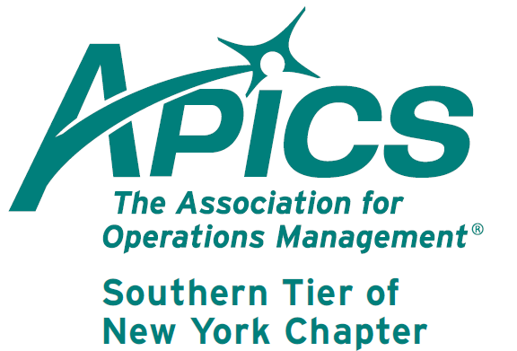
www.stapics.org

NO DINNER MEETING THIS MONTH

APICS Update from Don Sheldon, Director of Education

CPIM – Master Planning of Resources – By the time you read this, the first module of CPIM offered this summer is winding to a successful finish. We had a good class with people from a three different organizations plus one recent BU graduate attendee. We are in partnership with Broome Community College again to offer the next CPIM module, Master Planning of Resources. This is scheduled to start on campus on Monday 23 September 2013. Registration can be done through BCC at 607 778 5012. I will be the instructor again. The fee is $685 per student for non-APICS members (includes a membership) or $485 for APICS members per module. The module should be completed by early November with classes on Monday afternoons.

The dates for this BCC Offering are:
23 Sept 1-5 PM Lessons 1&2
7 Oct 1-5 PM Lessons 3&4
21 Oct 1-5 PM Lessons 5&6
4 Nov 1-5 PM Lessons 7&8

There will be a minimum class size to run the course. It is our intention to continue on through the CPIM series if there is interest.

If you are interested in any other Southern Tier offerings, please contact me at dsheldon@sheldoninc.com. Thanks!

Thanks!
Don Sheldon

Attend this year’s International Conference and earn up to 24 points towards your APICS certification maintenance.
Register today by visiting http://www.apics.org/sites/conference/annual/register/register,

APICS Foundation Announces New Name, Structure and Leadership
to Drive Innovation in Supply Chain and Operations Management
APICS Foundation advances supply chain innovation through research

CHICAGO (August 12, 2013) – APICS, the world’s largest and most respected association for supply chain and operations management professionals, today announced changes to the APICS Foundation that will better position the foundation to deliver quality education and thought leadership.

Click on below file to learn more.

6th Annual APICS Northeast District Student Case Competition
Please join us as a participant or in the audience to see firsthand the talent that our colleges and universities have to offer in both an undergraduate program and a graduate program. It is well worth the time and money!

When FRIDAY, February 7 and Saturday, February 8, 2014
Where Marriott Hotel WOLF ROAD Albany, New York

Find more details at www.apicsnortheast.org in the coming weeks.

What is a 'Student Case Competition'?

Teams of students are given a case study based on a real company with a specific operations management problem. Teams will develop solutions and present them in both written form and as an oral presentation.

Two separate flights, same case: undergraduate and graduate.
The entire competition, from receiving the case problem to presenting the team's solution, happens within two days.
*****************************************************
Why should you compete?
- Demonstrate your analytical and decision making skills
- Add a unique activity to your resume.
- Network with operations management professionals
- Opportunity to become an APICS student member
- Earn prize money! Grand Prize is an expense paid trip to the 2014 APICS International Conference.
- Each track will also provide
$800 for 1st, $600 for 2nd; and $400 for 3rdplace teams

Who is eligible to compete?
Any full-time or part-time university/college student. There are two competition divisions: undergraduate and graduate.
Teams must be made up of 3-4 students.
******************************************

What does it cost?
$195 per Team
Includes:
· Competition registration
· Pizza party Friday night
· Breakfast and Lunch Saturday
· Awards Reception Saturday
· Up to 2 rooms per Team for Saturday night
· 1 year APICS student membership for eligible students

Sponsorships - Chapters, Companies, Schools, Consultants ...
· Platinum: $2,000
· Gold: $1,000
· Silver: $500
· Bronze: $250
· Friend: up to $249
Please contact Jennifer Kevlin for more details on sponsorship options at northeastdm@apics.org

We’re on !!!
Come and visit, poke around, or comment on us! Our name there is “Southern Tier APICS”. It’s just another way
for us to keep in touch with our membership.


Autumn begins
September 22

Board of Directors 2013-2014

President

Dave Gardner, CPIM

dgardner@emtmetals.com

Executive VP /Director of Finance

Steve Whited

steven.whited@acco.com

Secretary

Debbie Unkel, CPIM

deb.unkel@raymondcorp.com

Director of Membership/Director of Chapter Standards/ Director of Online Publication

Lee Schechter , CPIM

lschechter@stny.rr.com

Director of Programming and Marketing

Michael LoSapio

Michael.LoSapio@SynergyResources.net

Director of Publicity

Kelly Norieka

Kelly.norieka@lmco.com

2nd Director of Publicity

Chris Reinwald

creinwald@gmail.com

Director of Education

Don Sheldon, CPIM, CIRM, CSCP

dsheldon@sheldoninc.com

Director at Large

Steve Stanchak, CPIM

steve.stanchak@infoprint.com

Director of Student Relations

Brian Arrnold

barnold@amphenol-aao.com

2nd Director of Student Relations

Don Sheldon, CPIM, CIRM, CSCP

dsheldon@sheldoninc.com

Director of Communications

April McWeeney, CPIM

april.mcweeney@acco.com

Southern Tier APICS
PO Box 1107
Binghamton NY 13902-1107

